Propulsion System of a drone

Charlie Nitschelm - 11/11/18
Project 2B Team Members: Thomas Collins and Joseph Williams

Description

A study on the effect of jet engine efficiency, performance, and overall cycle with assuming constant and non-constant specific heat within the range of a compressor pressure ratio of 1-50 and a maximum combustion chamber of 1000-2000 Kelvin.

Performance and efficiency

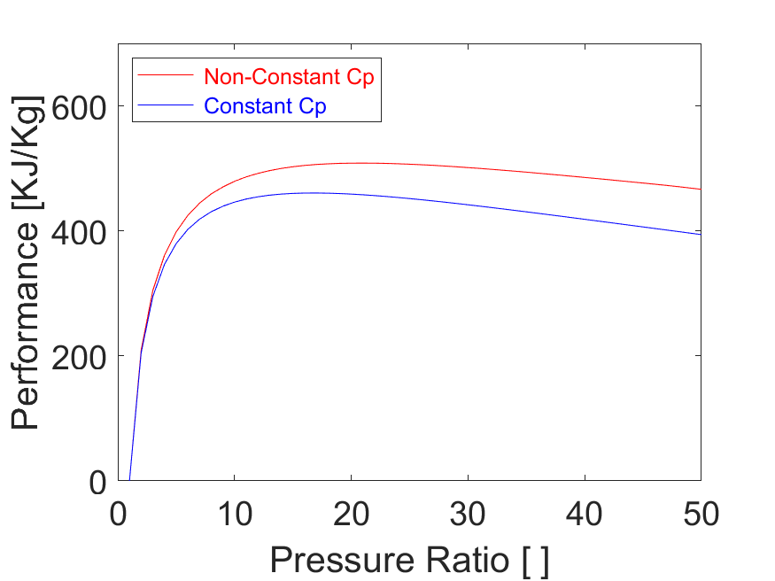
Figure 1 - Varying performance with changes in compressor pressure ratio

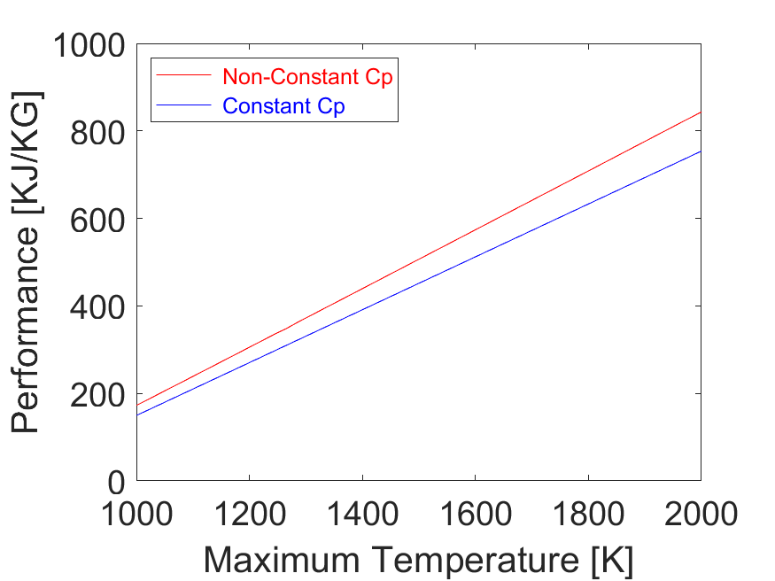
Figure 2 - Varying performance with changes in combustor maximum temperature

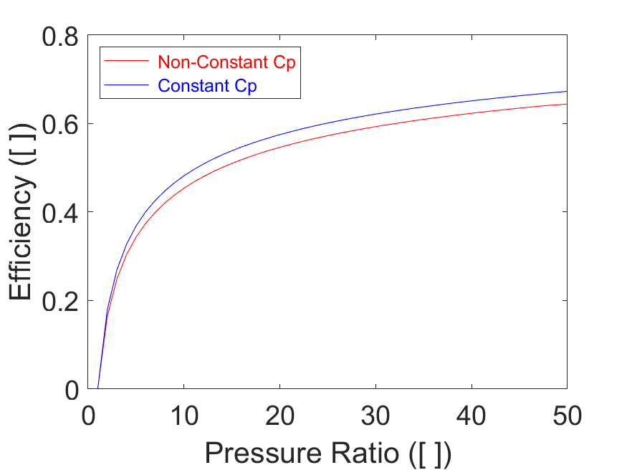
Figure 3 - Varying efficiency with changes in compressor pressure ratio

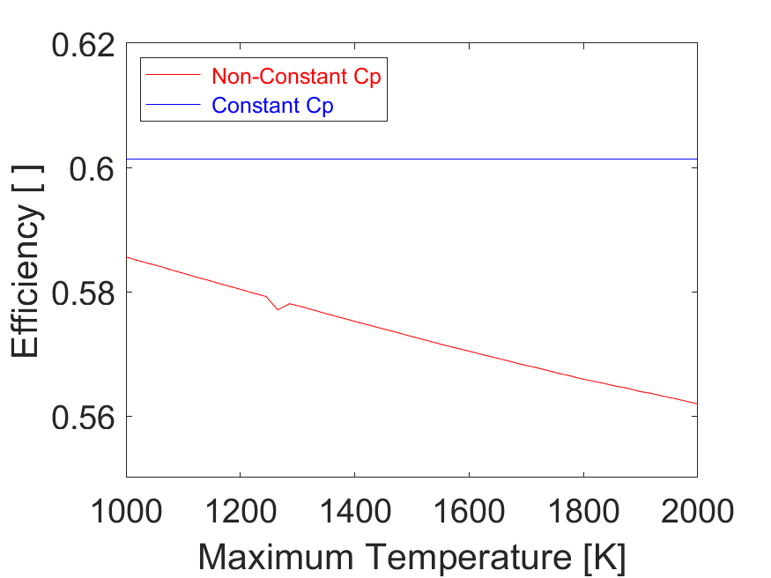
Figure 4 - Varying efficency with changes in combustor maximum temperature

- Figure 1 illustrates the increase in performance of the jet engine cycle with increasing pressure up to ~15 where it begins to level out and drop slighly. The difference between constant and non-constant specific heat illustrates the error involved assuming constant specific heat with large temperature changes.
- Figure 2 illustrates the linear rise in performance with an increase in maximum combustor temperature.
- For figures 1 and 2, pressure ratio shows a logarithmic growth and maximum combustor temperature shows a linear growth because performance rises linearly with the maximum temperature, but logarithmically with pressure ratio due to how the temperautre of each state is calculated, either logarithmically from the previous state or linearly.
- Figure 3 illustrates the increase in efficiency of the jet engine cycle with increasing pressure up to ~40 where it begins to level out and rise very slowly because the heat added to the system rises slighly faster then the heat rejected to the system with varying temperature.
- Figure 4 shows that efficiceny of the cycle with varying maximum combustor temperature is constant, but non-constant specific heat provides a decrease in efficiecny due to the error involved in specific enthalpy of each state within the cycle with increase temperature differences.

Performance and efficiency 3D
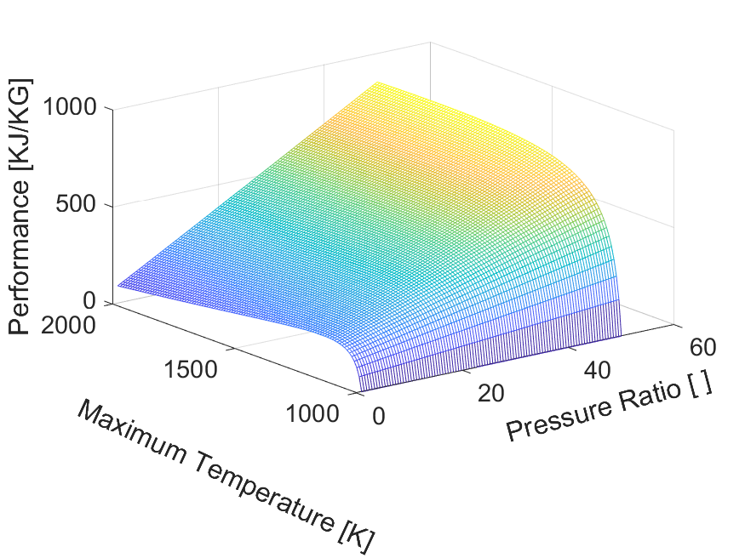
Figure 5 - Varying performance with changes in compressor pressure ratio and combustor maximum temperature
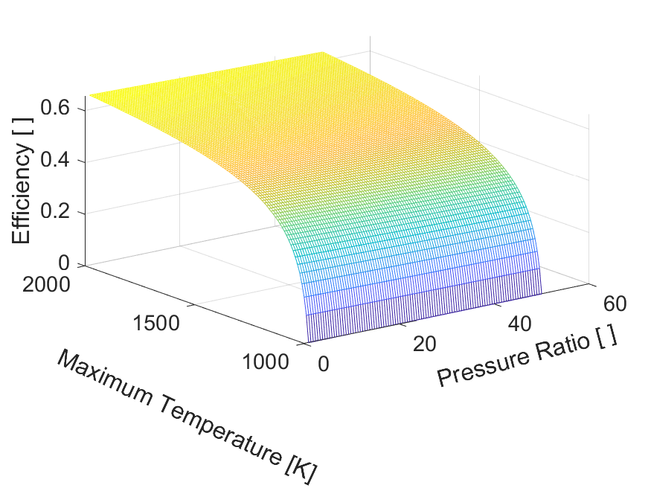
Figure 6 - Varying efficiency with changes in compressor pressure ratio and combustor maximum temperature

- Figure 5 combines the concepts seen before but in a 3D display. You can see that performance is affected logarithmically with respect to the pressure ratio, and affected linearly with maximum temperature, showing a nearly flat curves surface for the majoirt of the plot as the pressure ratio affect levels out.
- Figure 6 also combines the concepts seen before. Pressure ratio is the only parameter severly affecting the cycle efficiency, but maximum temperature does affect it slightly linearly.

Cycle variation for constant specific heat
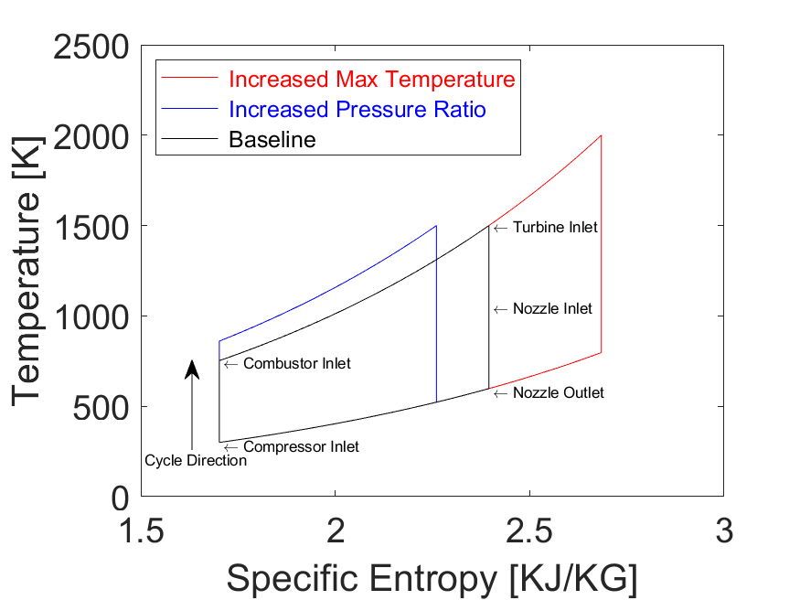
Figure 7 – An average temperature vs. specific entropy cycle assuming constant specific heat plotted with a higher compressor pressure ratio and a higher combustor maximum temperature cycle, respectively
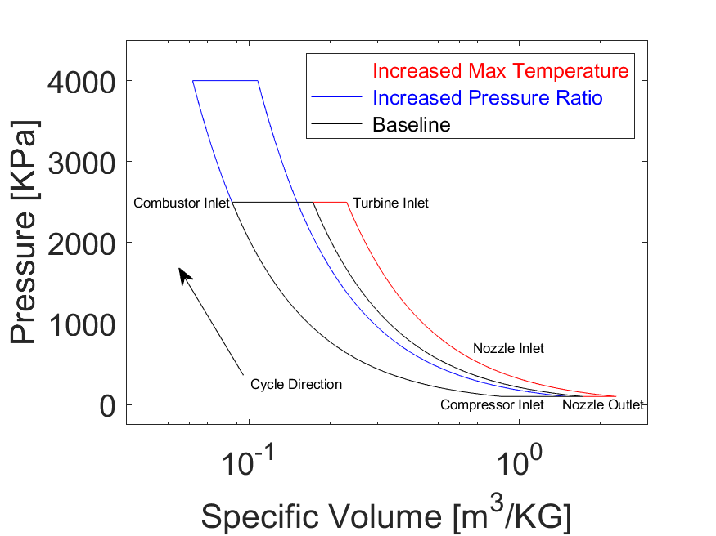
Figure 8 - An average pressure vs. specific volume cycle assuming constant specific heat plotted with a higher compressor pressure ratio and a higher combustor maximum temperature cycle, respectively

- Figure 7 and 8 detail the differences in overall cycle with various input parameters. The black cycle is a baseline with an input pressure and temperature at STP and a pressure ratio of 25 and a maximum combustor temperaure of 1500K. The red cycle has a maximum temperature of 2000K compared to the baseline cycle, and the blue cycle has a pressure ratio of 40 compared to the baseline cycle.

Cycle variation for constant and non-constant specific heat

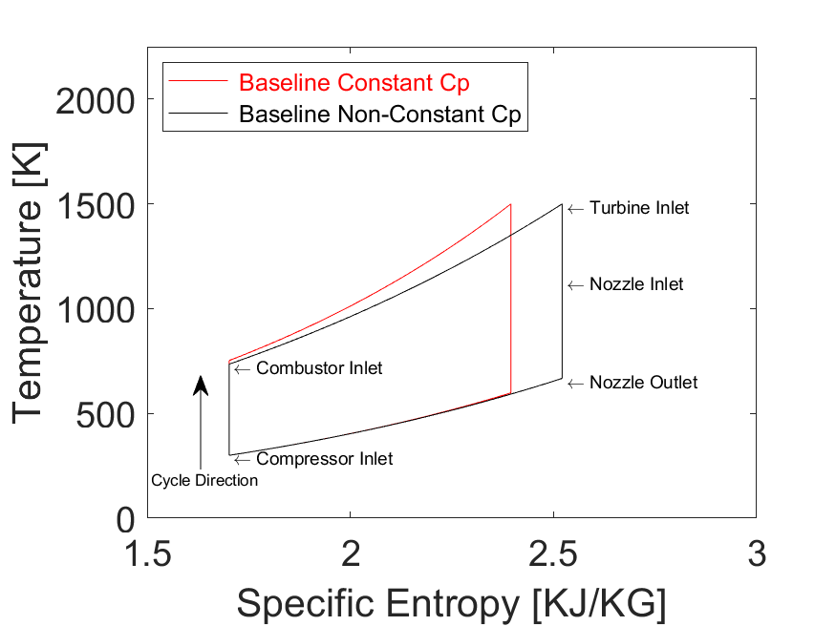
Figure 9 - Temperature vs. specific entropy of a cycle assuming constant specific heat, Cp, and non-constant specific heat
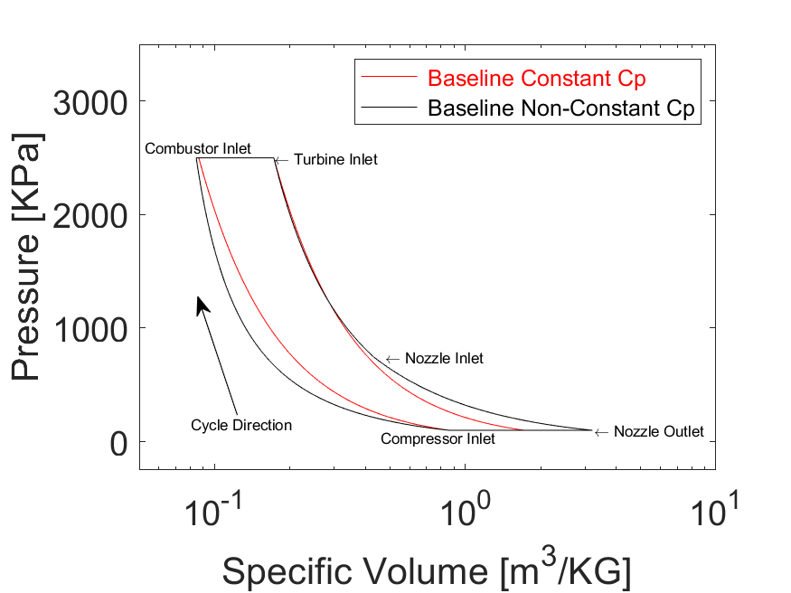
Figure 10 - Pressure vs. specific volume of a cycle assuming constant specific heat, Cp, and non-constant specific heats

- Figures 9 and 10 illustrate the differences involved within the baseline cycle explained above with constant and non-constant specific heat. From the figures, you can see that large variation is seen in the cycles overall shape as the error of specific enthalpy is inserted into the calculations with large temperature changes.

Appendix
Project Notes
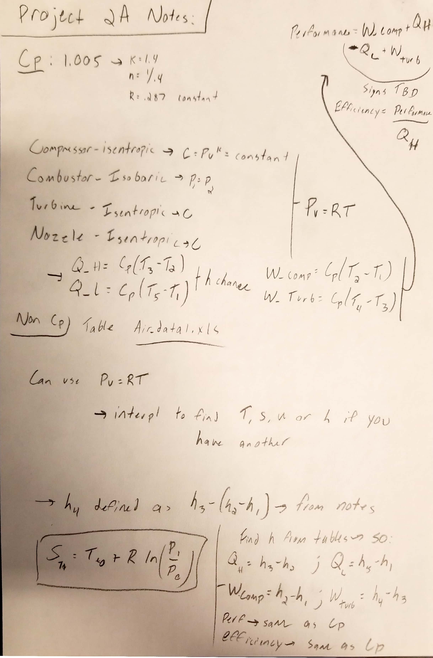
Figure 11 - Hand written notes for Project 2A

MATLAB Code

The code below utilized 4 function with a parent script used for further analysis and plotting. The main script will be attached with its functions after it.

Main Script

% Script to create all the graphs needed for report using
% functions within this folder
clear all;
close all;

%%%%%%%%%%
% Calculating Performance and Efficiency for Varying PR
%%%%%%%%%%

T1 = 300;
P1 = 100;
MaxT1 = 1500;
PR = linspace(1,50,50)';

EfficiencyPRNonCp = zeros(50,1);
PerformancePRNonCp = zeros(50,1);
EfficiencyPRCp = zeros(50,1);
PerformancePRCp = zeros(50,1);
for i = 1:50
[PerformancePRNonCp(i),EfficiencyPRNonCp(i)] = PerformanceEfficiencyNonCp(T1,P1,PR(i),MaxT1);
[PerformancePRCp(i),EfficiencyPRCp(i)] = PerformanceEfficiencyCp(T1,P1,PR(i),MaxT1);
end

%%%%%%%%%%
% Calculating Performance and Efficiency for Varying MaxT
%%%%%%%%%%

T1 = 300;
P1 = 100;
PR2 = 25;
MaxT = linspace(1000,2000,50)';

EfficiencyMaxTNonCp = zeros(50,1);
PerformanceMaxTNonCp = zeros(50,1);
EfficiencyMaxTCp = zeros(50,1);
PerformanceMaxTCp = zeros(50,1);
for i = 1:50
[PerformanceMaxTNonCp(i),EfficiencyMaxTNonCp(i)] = PerformanceEfficiencyNonCp(T1,P1,PR2,MaxT(i));
[PerformanceMaxTCp(i),EfficiencyMaxTCp(i)] = PerformanceEfficiencyCp(T1,P1,PR2,MaxT(i));
end

%%%%%%%%%%
% Calculating P,v,T and s data points for various parameters constant cp
%%%%%%%%%%

% Data for the baseline - average PR and MaxT
PR3 = 25;
MaxT2 = 1500;
[PressuresBase,SpecificVolumesBase,TemperaturesBase,SpecificEntropysBase] = CycleDataPvTsCp(PR3,MaxT2);

% Data for increased MaxT - average PR
PR4 = 25;
MaxT3 = 2000;
[PressuresMaxT,SpecificVolumesMaxT,TemperaturesMaxT,SpecificEntropysMaxT] = CycleDataPvTsCp(PR4,MaxT3);

% Data for increased PR - average MaxT
PR5 = 40;
MaxT4 = 1500;
[PressuresPR,SpecificVolumesPR,TemperaturesPR,SpecificEntropysPR] = CycleDataPvTsCp(PR5,MaxT4);

%%%%%%%%%%
% Calculating P,v,T and s data points for various parameters non constant cp
%%%%%%%%%%

% Data for the baseline - average PR and MaxT
PR3 = 25;
MaxT2 = 1500;
[PressuresBase2,SpecificVolumesBase2,TemperaturesBase2,SpecificEntropysBase2] = CycleDataPvTsNonCp(PR3,MaxT2);

% Data for increased MaxT - average PR
PR4 = 25;
MaxT3 = 2000;
[PressuresMaxT2,SpecificVolumesMaxT2,TemperaturesMaxT2,SpecificEntropysMaxT2] = CycleDataPvTsNonCp(PR4,MaxT3);

% Data for increased PR - average MaxT
PR5 = 40;
MaxT4 = 1500;
[PressuresPR2,SpecificVolumesPR2,TemperaturesPR2,SpecificEntropysPR2] = CycleDataPvTsNonCp(PR5,MaxT4);

% Bonus Problem, calculating efficiency and performance as a function of PR and MaxT

Res = 10;

PR2 = linspace(1,50,Res)';
MaxT3 = linspace(1000,2000,Res)';
T1 = 300;
P1 = 100;
[PRx,MaxTy] = meshgrid(PR2,MaxT3);
Performance = zeros(Res,Res);
Thermal_Efficiency = zeros(Res,Res);

for i = 1:Res
for j = 1:Res
[Performance(i,j),Thermal_Efficiency(i,j)] = PerformanceEfficiencyNonCp(T1,P1,PR2(i),MaxT3(j));
end
end

%%%%%%%%%%
% Plotting Data for Efficiency and Performance
%%%%%%%%%%

% Plot of Efficiency vs. Pressure Ratio
figure(1)
plot(PR,EfficiencyPRNonCp,'r')
hold on
plot(PR,EfficiencyPRCp,'b')
ylabel('Efficiency ([])','FontSize',20)
set(gca,'fontsize',18)
xlabel('Pressure Ratio ([])','FontSize',20)
set(gca,'fontsize',18)
lgd = legend('\color{red} Non-Constant Cp','\color{blue} Constant Cp','Location','northwest');
lgd.FontSize = 12;
hold off

% Plot of Performance vs. Pressure Ratio
figure(2)
plot(PR,PerformancePRNonCp,'r')
hold on
plot(PR,PerformancePRCp,'b')
ylabel('Performance [m^2/s^2]','FontSize',20)
set(gca,'fontsize',18)
xlabel('Pressure Ratio [ ]','FontSize',20)
set(gca,'fontsize',18)
xlim([0,50])
ylim([0,700])
lgd = legend('\color{red} Non-Constant Cp','\color{blue} Constant Cp','Location','northwest');
lgd.FontSize = 12;
hold off

% Plot of Efficiency vs. Maximum Temperature
figure(3)
plot(MaxT,EfficiencyMaxTNonCp,'r')
hold on
plot(MaxT,EfficiencyMaxTCp,'b')
ylabel('Efficiency [ ]','FontSize',20)
set(gca,'fontsize',18)
xlabel('Maximum Temperature [K]','FontSize',20)
set(gca,'fontsize',18)
xlim([1000,2000])
ylim([.55,.62])
lgd = legend('\color{red} Non-Constant Cp','\color{blue} Constant Cp','Location','northwest');
lgd.FontSize = 12;
hold off

% Plot of Performance vs. Maximum Temperature
figure(4)
plot(MaxT,PerformanceMaxTNonCp,'r')
hold on
plot(MaxT,PerformanceMaxTCp,'b')
ylabel('Performance [m^2/s^2]','FontSize',20)
set(gca,'fontsize',18)
xlabel('Maximum Temperature [K]','FontSize',20)
set(gca,'fontsize',18)
lgd = legend('\color{red} Non-Constant Cp','\color{blue} Constant Cp','Location','northwest');
lgd.FontSize = 12;
hold off

%%%%%%%%%%
% Bonus 3D Plots
%%%%%%%%%%

figure(5)
mesh(PRx,MaxTy,Thermal_Efficiency)
xlabel('Pressure Ratio [ ]','Rotation',15,'FontSize',15)
set(gca,'fontsize',14)
ylabel('Maximum Temperature [K]', 'Rotation',-25,'FontSize',15)
set(gca,'fontsize',14)
zlabel('Efficiency [ ]', 'Interpreter', 'none','FontSize',15)
set(gca,'fontsize',14)
hold off

figure(6)
mesh(PRx,MaxTy,Performance)
xlabel('Pressure Ratio [ ]','Rotation',15,'FontSize',15)
set(gca,'fontsize',14)
ylabel('Maximum Temperature [K]', 'Rotation',-25,'FontSize',15)
set(gca,'fontsize',14)
zlabel('Performance [m^2/s^2]','FontSize',15)
set(gca,'fontsize',14)
hold off

%%%%%%%%%%
% Cycle Graphs Constant Cp
%%%%%%%%%%

% Plot of Pressure vs. Specific Volume
figure(7)
semilogx(SpecificVolumesMaxT,PressuresMaxT,'r',SpecificVolumesPR,PressuresPR,'b',SpecificVolumesBase,PressuresBase,'k')

text(SpecificVolumesBase(1)-.35 ,PressuresBase(1)-90 , 'Compressor Inlet','FontSize',8)
text(SpecificVolumesBase(1001)-.049,PressuresBase(1001), 'Combustor Inlet','FontSize',8)
text(SpecificVolumesBase(2001)+.07,PressuresBase(2001), 'Turbine Inlet','FontSize',8)
text(SpecificVolumesBase(3001)+.25,PressuresBase(3001), 'Nozzle Inlet','FontSize',8)
text(SpecificVolumesBase(4001)-.27,PressuresBase(4001)-90, 'Nozzle Outlet','FontSize',8)
annotation('textarrow',[.34,.25],[.3,.5],'String','Cycle Direction','FontSize',8)

ylabel('Pressure [KPa]','FontSize',20)
set(gca,'fontsize',18)
xlabel('Specific Volume [m^3/kg]','FontSize',20)
set(gca,'fontsize',18)
xlim([.035,3])
ylim([-250,4500])
lgd = legend('\color{red} Increased Max Temperature','\color{blue} Increased Pressure Ratio','\color{black} Baseline');
lgd.FontSize = 12;
hold off

% Plot of Temperature vs. Specific Entropy
figure(8)
plot(SpecificEntropysMaxT,TemperaturesMaxT,'r',SpecificEntropysPR,TemperaturesPR,'b',SpecificEntropysBase,TemperaturesBase,'k')

text(SpecificEntropysBase(1)+.01 ,TemperaturesBase(1)-15 , '\leftarrow Compressor Inlet','FontSize',8)
text(SpecificEntropysBase(1001)+.01,TemperaturesBase(1001)-10, '\leftarrow Combustor Inlet','FontSize',8)
text(SpecificEntropysBase(2001)+.01,TemperaturesBase(2001), '\leftarrow Turbine Inlet','FontSize',8)
text(SpecificEntropysBase(3001)+.01,TemperaturesBase(3001), '\leftarrow Nozzle Inlet','FontSize',8)
text(SpecificEntropysBase(4001)+.01,TemperaturesBase(4001)-15, '\leftarrow Nozzle Outlet','FontSize',8)
annotation('textarrow',[.24,.24],[.25,.4],'String','Cycle Direction','FontSize',8)

ylabel('Temperature [K]','FontSize',20)
set(gca,'fontsize',18)
xlabel('Specific Entropy [KJ/KG]','FontSize',20)
set(gca,'fontsize',18)
xlim([1.5,3])
ylim([0,2500])
lgd = legend('\color{red} Increased Max Temperature','\color{blue} Increased Pressure Ratio','\color{black} Baseline','Location','northwest');
lgd.FontSize = 12;
hold off

%%%%%%%%%%
% Cycle Graphs Non-Constant Cp and constant for baseline
%%%%%%%%%%

% Plot of Pressure vs. Specific Volume
figure(9)
semilogx(SpecificVolumesBase,PressuresBase,'r',SpecificVolumesBase2,PressuresBase2,'k')

text(SpecificVolumesBase2(1)-.4 ,PressuresBase2(1)-60 , 'Compressor Inlet','FontSize',8)
text(SpecificVolumesBase2(1001)-.032,PressuresBase2(1001)+90, 'Combustor Inlet','FontSize',8)
text(SpecificVolumesBase2(2001),PressuresBase2(2001), '\leftarrow Turbine Inlet','FontSize',8)
text(SpecificVolumesBase2(3001)+.05,PressuresBase2(3001), '\leftarrow Nozzle Inlet','FontSize',8)
text(SpecificVolumesBase2(4001)+1.35,PressuresBase2(4001), '\leftarrow Nozzle Outlet','FontSize',8)
annotation('textarrow',[.30,.25],[.3,.5],'String','Cycle Direction','FontSize',8)

ylabel('Pressure [KPa]','FontSize',20)
set(gca,'fontsize',18)
xlabel('Specific Volume [m^3/kg]','FontSize',20)
set(gca,'fontsize',18)
xlim([.05,10])
ylim([-250,3500])
lgd = legend('\color{red} Baseline Constant Cp','\color{black} Baseline Non-Constant Cp');
lgd.FontSize = 12;
hold off

% Plot of Temperature vs. Specific Entropy
figure(10)
plot(SpecificEntropysBase,TemperaturesBase,'r',SpecificEntropysBase2,TemperaturesBase2,'k')

text(SpecificEntropysBase2(1)+.01 ,TemperaturesBase2(1)-15 , '\leftarrow Compressor Inlet','FontSize',9)
text(SpecificEntropysBase2(1001)+.01,TemperaturesBase2(1001)-15, '\leftarrow Combustor Inlet','FontSize',9)
text(SpecificEntropysBase2(2001)+.01,TemperaturesBase2(2001)-15, '\leftarrow Turbine Inlet','FontSize',9)
text(SpecificEntropysBase2(3001)+.01,TemperaturesBase2(3001) , '\leftarrow Nozzle Inlet','FontSize',9)
text(SpecificEntropysBase2(4001)+.01,TemperaturesBase2(4001)-15, '\leftarrow Nozzle Outlet','FontSize',9)
annotation('textarrow',[.24,.24],[.25,.4],'String','Cycle Direction','FontSize',8)

ylabel('Temperature [K]','FontSize',20)
set(gca,'fontsize',18)
xlabel('Specific Entropy [KJ/kg]','FontSize',20)
set(gca,'fontsize',18)
xlim([1.5,3])
ylim([0,2250])
lgd = legend('\color{red} Baseline Constant Cp','\color{black} Baseline Non-Constant Cp','Location','northwest');
lgd.FontSize = 12;
hold off

% Saving All Figures into Directory

saveas(figure(1) ,'Efficiency_PR.png')
saveas(figure(2) ,'Performance_PR.png')
saveas(figure(3) ,'Efficiency_MaxT.png')
saveas(figure(4) ,'Performance_MaxT.png')
saveas(figure(5) ,'Efficiency_PR_MaxT.png')
saveas(figure(6) ,'Performance_PR_MaxT.png')
saveas(figure(7) ,'P_v_Constant_Cp.png')
saveas(figure(8) ,'T_s_Constant_Cp.png')
saveas(figure(9) ,'P_v_Cp_NonCp.png')
saveas(figure(10),'T_s_Cp_NonCp.png')

T-s amd P-v Function for Constant Specific Heat

function [Pressure_Cycle,SpecificVolume_Cycle,Temperature_Cycle,SpecificEntropy_Cycle] = CycleDataPvTsCp(PR,MaxT)

% Thermal Systems - Project 2A
% Function to obtain P-v and T-s data for constant cp

Air_Data = xlsread('air_data1.xls');
Temperatures = Air_Data(:,1);
Specific_Entropy = Air_Data(:,4);

%%%%%%
% Definition of Constants
%%%%%%
R=0.287; % Constant
n=1.4; % Constant
k = (1/0.4); % Constant
Cp = 1.005; % kJ/Kg

%%%%%%
% State Calculations
%%%%%%

% State 1 % Inlet of Compressor
T1 = 300; % Inlet Temperature
P1 = 100; % Inlet Pressure
v1 = (R*T1)/P1;
s1 = interp1(Temperatures,Specific_Entropy,T1);
C=(P1*(v1^n)); % Isentropic Constant

% State 2 % Inlet of Combuster
P2 = PR*P1;
v2 = (C/P2)^(1/n);
T2= (P2*v2)/R;
s2 = s1;

% State 3 % Inlet of Turbine
P3 = P2; % Isobaric Process
v3 = (R * MaxT)/P3;
s3 = s2 + Cp*log(MaxT/T2);
C2=(P3*(v3^n));

% State 4 % Inlet of Nozzle
T4 = MaxT - (T2-T1);
v4 = ((P3 * (v3^n))/(R*T4))^(k);
P4 = (R * T4)/v4;
s4 = s3;

% State 5 % Outlet of Nozzle
P5 = P1;
v5 = ((P4*(v4^n))/P5)^(1/n);
T5 = (P5*v5)/R;
s5 = s1;

%%%%%%
% Process Calculations
%%%%%%

% Compressor - Isentropic
% Combustor - Isobaric
% Turbine - Isentropic
% Nozzle - Isentropic

% Compressor Process - Isentropic - P as a function of v

v_Compressor = linspace(v1,v2,1000)';
T_Compressor = linspace(T1,T2,1000)';
P_Compressor = zeros(1000,1);
s_Compressor = zeros(1000,1);

for index = 1:1000
P_Compressor(index) = C/(v_Compressor(index)^n);
s_Compressor(index) = s1;
end

% Combustor Process - Isobaric - T as a function of s

v_Combustor = linspace(v2,v3,1000)';
T_Combustor = linspace(T2,MaxT,1000)';
P_Combustor = zeros(1000,1);
s_Combustor = zeros(1000,1);

for index = 1:1000
s_Combustor(index) = s2 + Cp*log(T_Combustor(index)/T2);
P_Combustor(index) = P2;
end

% Turbine Process - Isentropic - P as a function of v

v_Turbine = linspace(v3,v4,1000)';
T_Turbine = linspace(MaxT,T4,1000)';
P_Turbine = zeros(1000,1);
s_Turbine = linspace(s3,s4,1000)';

for index = 1:1000
P_Turbine(index) = C2/(v_Turbine(index)^n);
end

% Nozzle Process - Isentropic - P as a function of v

v_Nozzle = linspace(v4,v5,1000)';
T_Nozzle = linspace(T4,T5,1000)';
P_Nozzle = zeros(1000,1);
s_Nozzle = zeros(1000,1);

for index = 1:1000
P_Nozzle(index) = C2/(v_Nozzle(index)^n);
s_Nozzle(index) = s4;
end

% Reset Process - 4 to 1 - Isobaric

v_Reset = linspace(v5,v1,1000)';
P_Reset = linspace(P5,P1,1000)';
T_Reset = linspace(T5,T1,1000)';
s_Reset = zeros(1000,1);
for index = 1:1000
P_Reset(index) = P5;
s_Reset(index) = s4 + Cp*log(T_Reset(index)/T5);
end

% Data Compiled for Output - 1000 points per process
Pressure_Cycle = [P_Compressor;P_Combustor;P_Turbine;P_Nozzle;P_Reset];
SpecificVolume_Cycle = [v_Compressor;v_Combustor;v_Turbine;v_Nozzle;v_Reset];
Temperature_Cycle = [T_Compressor;T_Combustor;T_Turbine;T_Nozzle;T_Reset];
SpecificEntropy_Cycle = [s_Compressor;s_Combustor;s_Turbine;s_Nozzle;s_Reset];
end

T-s amd P-v Function for Non-Constant Specific Heat

function [Pressure_Cycle,SpecificVolume_Cycle,Temperature_Cycle,SpecificEntropy_Cycle] = CycleDataPvTsNonCp(PR,MaxT)

% Thermal Systems - Project 2A
% Function to obtain P-v and T-s data for non constant cp

%%%%%%
% Definition of Constants
%%%%%%
Air_Data = xlsread('air_data1.xls');
Temperatures = Air_Data(:,1);
Specific_Enthalpy = Air_Data(:,3);
Specific_Entropy = Air_Data(:,4);

R=0.287; % Constant

%%%%%%
% State Calculations
%%%%%%

% State 1 % Inlet of Compressor
P1 = 100; % Constant
T1 = 300; % Constant
v1 = (R*T1)/P1;
s1 = interp1(Temperatures,Specific_Entropy,T1);
st1 = interp1(Temperatures,Specific_Entropy,T1);
h1 = interp1(Specific_Entropy,Specific_Enthalpy,s1);

% State 2 % Inlet of Combuster
P2 = PR*P1;
s2 = s1;
st2 = st1 + R*log(PR);
T2 = interp1(Specific_Entropy,Temperatures,st2);
h2 = interp1(Temperatures,Specific_Enthalpy,T2);
v2 = R*T2/P2;

% State 3 % Inlet of Turbine
P3 = P2; % Isobaric Process
s3 = interp1(Temperatures,Specific_Entropy,MaxT)-st2+s2;
st3 = interp1(Temperatures,Specific_Entropy,MaxT);
v3 = (R * MaxT)/P3;
h3 = interp1(Temperatures,Specific_Enthalpy,MaxT);

% State 4 % Inlet of Nozzle
s4 = s3;
h4 = h3 - (h2-h1);
T4 = interp1(Specific_Enthalpy,Temperatures,h4);
st4 = interp1(Temperatures,Specific_Entropy,T4);
P4 = P3*(exp((st4-st3)/R));
v4 = R*T4/P4;

% State 5 % Outlet of Nozzle
s5 = s4;
P5 = P1;
st5 = st4 + R*log(P5/P4);
T5 = interp1(Specific_Entropy,Temperatures,st5) ;
v5 = (R*T5)/P5;
h5 = interp1(Temperatures,Specific_Enthalpy,T5);

%%%%%%
% Process Calculations
%%%%%%

% Compressor - Isentropic
% Combustor - Isobaric
% Turbine - Isentropic
% Nozzle - Isentropic

% Compressor Process - Isentropic - P as a function of v

P_Compressor = linspace(P1,P2,1000)';
s_Compressor = zeros(1000,1);
T_Compressor = linspace(T1,T2,1000)';
v_Compressor = zeros(1000,1);

for index = 1:1000
s_Compressor(index) = s1;
v_Compressor(index) = R*T_Compressor(index)/P_Compressor(index);
end

% Combustor Process - Isobaric - T as a function of s

P_Combustor = zeros(1000,1);
v_Combustor = linspace(v2,v3,1000)';
T_Combustor = linspace(T2,MaxT,1000)';
s_Combustor = zeros(1000,1);

for index = 1:1000
P_Combustor(index) = P2;
s_Combustor(index) = (interp1(Temperatures,Specific_Entropy,T_Combustor(index)))-st2+s2;
end

% Turbine Process - Isentropic - P as a function of v
s_Turbine = linspace(s3,s4,1000)';
v_Turbine = zeros(1000,1);
T_Turbine = linspace(MaxT,T4,1000)';
P_Turbine = linspace(P3,P4,1000)';

for index = 1:1000
v_Turbine(index) = R*T_Turbine(index)/P_Turbine(index);
end

% Nozzle Process - Isentropic - P as a function of v

s_Nozzle = zeros(1000,1);
v_Nozzle = zeros(1000,1);
T_Nozzle = linspace(T4,T5,1000)';
P_Nozzle = linspace(P4,P5,1000)';

for index = 1:1000
s_Nozzle(index) = s4;
v_Nozzle(index) = R*T4/P_Nozzle(index);
end

% Reset Process - 4 to 1 - Isobaric

v_Reset = linspace(v5,v1,1000)';
P_Reset = zeros(1000,1);
T_Reset = linspace(T5,T1,1000)';
s_Reset = zeros(1000,1);

for index = 1:1000
P_Reset(index) = P5;
s_Reset(index) = interp1(Temperatures,Specific_Entropy,T_Reset(index))-st1+s1;
end

% Data Compiled for Output - 1000 points per process
Pressure_Cycle = [P_Compressor;P_Combustor;P_Turbine;P_Nozzle;P_Reset];
SpecificVolume_Cycle = [v_Compressor;v_Combustor;v_Turbine;v_Nozzle;v_Reset];
Temperature_Cycle = [T_Compressor;T_Combustor;T_Turbine;T_Nozzle;T_Reset];
SpecificEntropy_Cycle = [s_Compressor;s_Combustor;s_Turbine;s_Nozzle;s_Reset];
end

Performance and Efficiency Function for Constant Specific Heat

function [Performance,Thermal_Efficiency] = PerformanceEfficiencyCp(T1,P1,PR,MaxT)

% Thermal Systems - Project 2A
% Function to obtain performance and efficient of a jet engine with particular parameters for constant cp

%%%%%%
% Definition of Constants
%%%%%%

R=0.287; % Constant
n=1.4; % Constant
k = (1/0.4); % Constant
Cp = 1.005; % kJ/Kg

%%%%%%
% State Calculations
%%%%%%

% State 1 % Inlet of Compressor
v1 = (R*T1)/P1;
s1 = 1;
C=(P1*(v1^n)); % Isentropic Constant

% State 2 % Inlet of Combuster
P2 = PR*P1;
v2 = (C/P2)^(1/n);
T2= (P2*v2)/R;
s2 = 1;

% State 3 % Inlet of Turbine
P3 = P2; % Isobaric Process
v3 = (R * MaxT)/P3;
s3 = s2 + Cp*log(MaxT/T2);

% State 4 % Inlet of Nozzle
T4 = MaxT - (T2-T1);
v4 = ((P3 * (v3^n))/(R*T4))^(k);
P4 = (R * T4)/v4;
s4 = s3;

% State 5 % Outlet of Nozzle
P5 = P1;
v5 = ((P4*(v4^n))/P5)^(1/n);
T5 = (P5*v5)/R;
s5 = s1;

%%%%%
% Calculating the variables needed to find the
% overall efficiency and performance of the jet engine
%%%%%

Q_Add = Cp*(MaxT-T2);
Q_Remove = Cp*(T5-T1);

W_Compressor = Cp*(T2-T1);
W_Turbine = Cp*(T4-MaxT);

Performance = W_Compressor + Q_Add - Q_Remove + W_Turbine;
Thermal_Efficiency = Performance/Q_Add; % Dimensionless Parameter

end

Performance and Efficiency Function for Non-Constant Specific Heat

function [Performance,Thermal_Efficiency] = PerformanceEfficiencyNonCp(T1,P1,PR,MaxT)

% Thermal Systems - Project 2A
% Function to obtain performance and efficient of a jet engine with particular parameters for non constant cp

%%%%%%
% Definition of Constants
%%%%%%
Air_Data = xlsread('air_data1.xls');
Temperatures = Air_Data(:,1);
Internal_Energy = Air_Data(:,3);
Specific_Entropy = Air_Data(:,4);

R=0.287; % Constant

%%%%%%
% State Calculations
%%%%%%

% State 1 % Inlet of Compressor
v1 = (R*T1)/P1;
s1 = interp1(Temperatures,Specific_Entropy,T1);
h1 = interp1(Specific_Entropy,Internal_Energy,s1);
st1 = s1;

% State 2 % Inlet of Combuster
P2 = PR*P1;
s2 = s1;
st2 = st1 + R*log(PR);
T2 = interp1(Specific_Entropy,Temperatures,st2);
h2 = interp1(Temperatures,Internal_Energy,T2);
v2 = R*T2/P2;

% State 3 % Inlet of Turbine
P3 = P2; % Isobaric Process
s3 = interp1(Temperatures,Specific_Entropy,MaxT)-st2+s2;
st3 = interp1(Temperatures,Specific_Entropy,MaxT);
v3 = (R * MaxT)/P3;
h3 = interp1(Temperatures,Internal_Energy,MaxT);

% State 4 % Inlet of Nozzle
s4 = s3;
T4 = interp1(Specific_Entropy,Temperatures,s4);
st4 = interp1(Temperatures,Specific_Entropy,T4);
h4 = h3 - (h2-h1);
P4 = P3*(exp((st4-st3)/R));
v4 = R*T4/P4;

% State 5 % Outlet of Nozzle
s5 = s4;
P5 = P1;
st5 = st4 + R*log(P5/P4);
T5 = interp1(Specific_Entropy,Temperatures,st5) ;
v5 = (R*T5)/P5;
h5 = interp1(Temperatures,Internal_Energy,T5);

%%%%%
% Calculating the variables needed to find the
% overall efficiency and performance of the jet engine
%%%%%

Q_Add = h3 - h2;
Q_Remove = h5 - h1;

W_Compressor = h2 - h1;
W_Turbine = h4 - h3;

Performance = W_Compressor + Q_Add - Q_Remove + W_Turbine;
Thermal_Efficiency = Performance/Q_Add;

end

